Name _________________________________________ Core _____
Astronomy Study Guide
- What is rotation? ___________________________________________________________________
  - How long does it take for Earth to rotate? _____________________
- What is revolution? ____________________________________________________________________
  - How long does it take for Earth to revolve? ____________________
- Label the diagram below with the seasons in the Northern hemisphere: summer, spring, winter, fall and the motions: rotation and revolution

- When it is Spring in the Northern Hemisphere it is _____________________ in the Southern Hemisphere.

- Describe the characteristics of the inner planets. (size, composition, moons, mass, density) _________________
___________________________________________________________________________________________

- Describe the characteristics of the outer planets. (size, composition, moons, mass, density) ______________
___________________________________________________________________________________________

- What objects are found in our solar system? _______________________________________________________
___________________________________________________________________________________________

- What causes seasons? _________________________________________________________________________

- What time of year are the sun’s rays most direct? _____________________ Least direct? ___________________
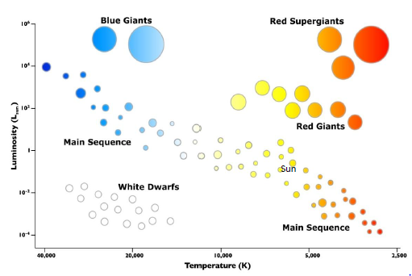
- What factor affects the color of a star?
________________________________

- What factor affects the luminosity?
________________________________

- Is the temperature of white dwarfs higher or lower than red giants?
________________________________

- What color are the stars with the highest temp? ___________________
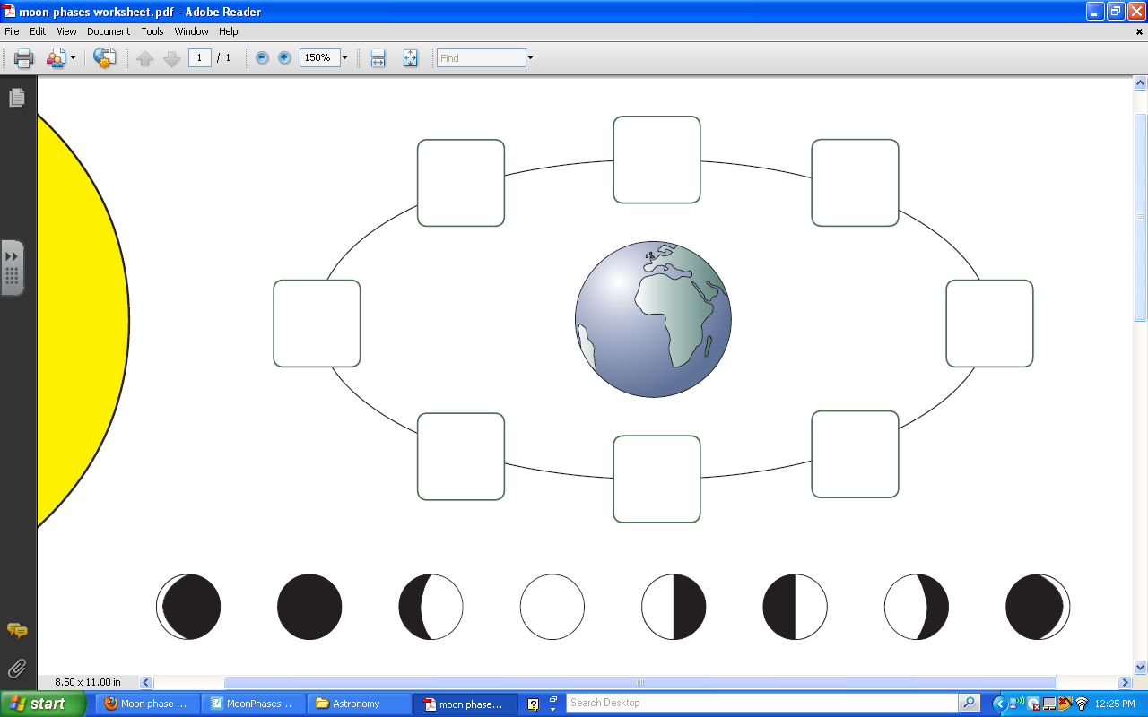
- Draw in the correct phase of moon. (shaded portion represents the part of the moon you cannot see!)

SUN

- Why does the moon’s appearance change throughout the month? _____________________________________
___________________________________________________________________________________________

- When the lighted side of the moon appears to get bigger, what is that called? _____________________

- When the lighted side appears to get smaller, what is that called? ________________________

- Draw both a solar and lunar eclipse in the boxes below and label the sun, moon, and Earth in each picture.
Lunar Eclipse
Solar Eclipse

- Why don’t eclipses occur every month? __________________________________________________________
___________________________________________________________________________________________

- How do the phases of the moon affect tides? ______________________________________________________
___________________________________________________________________________________________
___________________________________________________________________________________________

- What is a spring and neap tide? _________________________________________________________________
___________________________________________________________________________________________

- What is a high and low tide? ____________________________________________________________________
___________________________________________________________________________________________

