Climate Study Guide Name________________________________________________________

- The diagram below shows the Greenhouse Effect. Describe each number.
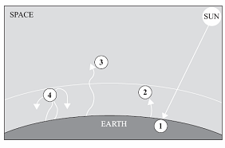

1.

2.

3.

4.

- Greenhouse gasses include ____________________________________________________________________.

- Describe the Greenhouse effect in your own words.

- What are some negative impacts of climate change?

- How can climate change be reversed?

- Create a Venn diagram of Weather vs. Climate. Compare their similarities and differences.

- What role does Carbon dioxide play in the greenhouse effect? Why is too much Carbon Dioxide in the atmosphere bad?

- Observe the graphs to answer the questions.

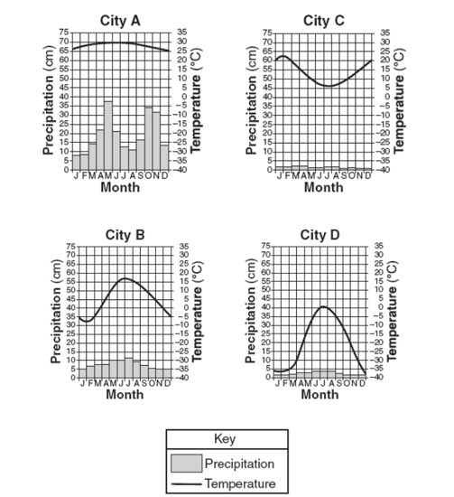
9a. Which graph mostly likely represents a tropical climate? ______________________

b. How do you know?

c. Which graph(s) most likely represents a temperate climate? __________________________

d. How do you know?

e. Which graph most likely represents a polar climate? _________________________

f. How do you know?

- Use your foldable notes to answer these questions.

- What is the relationship between elevation and temperature?

- What is the relationship between latitude and temperature?

- How does latitude affect climate?

- ____________________________ ocean currents are driven by wind and affect climate by _________________
___________________________________________________.

- How does a location near large bodies of water affect climate?

- How does an inland location affect climate?

READ through your notes and study them. Review your vocabulary in the “Ins”

