Name_________________________ Core_________________
2. Summary: Write a well developed paragraph that describes in your own words the four different types of fronts and the type of weather the front brings.
________________________________________________________________________________________________________________________________________________________________________________________________________________________________________________________________________________________________________________________________________________________________________________________________________________________________________________________________________________________________________________________________________________________________________________________________________________________________________________________________________________________________________________________________________________________________________________________________________________________________________________________________________________________________________________________________________________________________________________________________________________________________________________

- Read and ANNOTATE the chart below
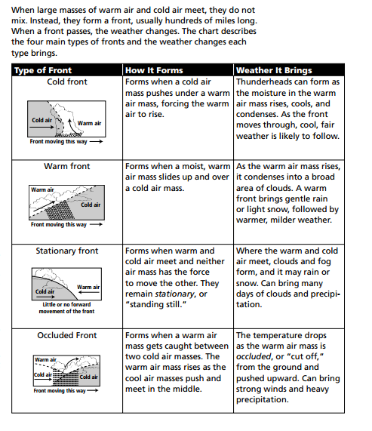
Use the map on the back of this page to answer the questions in complete sentences.

