Name Period

Graphing Speed
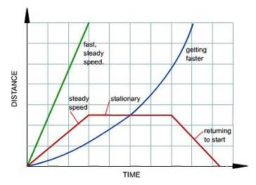

INTERPRETING GRAPHS-
In physics, a graph is “worth a thousand numbers”. A great deal of information can be obtained by looking and interpreting graphs describing motion (displacement, speed, velocity, and acceleration).

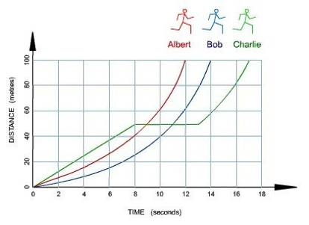
Distance vs. Time Graphs- To the right is a typical graph displaying Distance vs. Time. One or more objects may be graphed at one time, so you can compare the relative positions, speeds and displacement as they relate to each other.

Directions: Answer the following questions as they apply to the Motions graphs and diagrams.

Graph 1: Questions 1-7

- What does the slope of each line on the graph tell you?

- Which runner completed the 100m race in the least amount of time? What was his time?

- Which runner started out the fastest?

- What was Charlie doing between 8 seconds and 10.5 seconds?

- What does a straight line on this graph tell you? A curved line?

- At what distance and time did Albert overtake Bob?

Graph 2: Questions 8-13

- What is happening between 9AM and 11AM?

- What do you think bicyclist is doing between 11AM and 1PM?

- What was the total distance covered by 11AM, 1PM, and 4PM?

Graph 2

- What was the average speed of the bicyclist between 9Am and 11AM?

- Is the speed a positive or negative number? Could speed ever be a negative number?

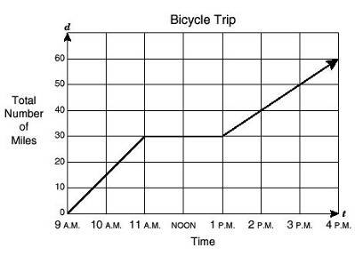

Describe the motion at each numbered location of the graph.














