Weather Study Guide Name_________________________________________________________

Directions: You weather final exam will be on ______________________________. Complete this study guide to prepare for your assessment.

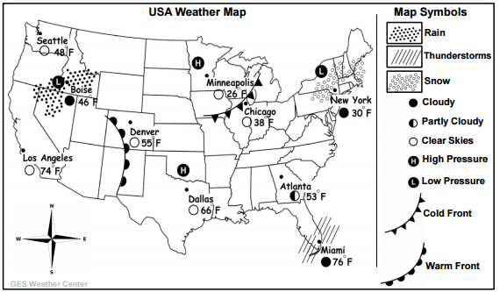

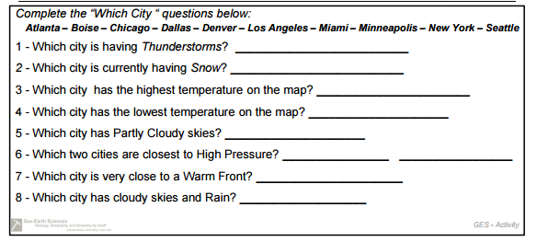

9. Fill in the table.
Symbol | Type of Weather | Explanation of Weather
H | Clear and Sunny Skies
 |  | Air pressure is low enough that water can evaporate and condense to form clouds.
10. Vocabulary: Fill in the chart

Word | Definition
Density

Air Pressure

Air Mass

Front

11. Sketch/Draw the water cycle below and label the following.
Evaporation-Transpiration-Condensation-Precipitation-Runoff-Groundwater

12. Describe the Coriolis Effect and the role it plays in creating global wind.

13. Describe the role High and Low pressure plays in creating wind currents.

14. How does elevation effect air pressure?

15. Fill in the chart.

Front | Symbol | How it forms/picture | Type of Weather
Cold
Warm
Stationary

16. Earth’s atmosphere is divided into layers based on ___________________________________.

17. Weather occurs in the ______________________________________ (layer of atmosphere)

18. What weather conditions are associated with tornados?

19. What is the relationship between temperature and density?

20. Label the following with Conduction, Convection, and Radiation
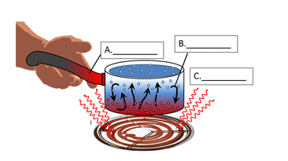
21. What does Doppler radar measure?

22. Describe an appropriate safety plan during a hurricane.

23. Describe an appropriate safety plan during a tornado.

24. Describe how the uneven heating of Earth is a cause of wind.

25.

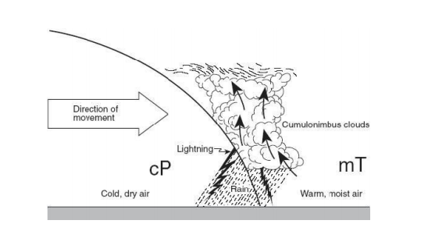

- Why does the air rise in the picture above?

- What type of front is this? How do you know?

